Ej 1: Instalar ClamAV y ClamTK en Kali Linux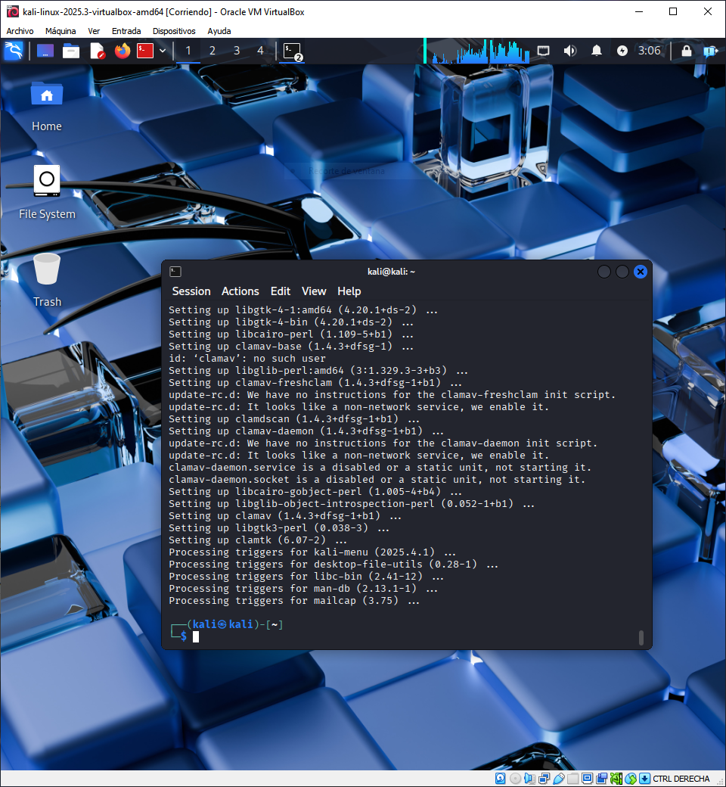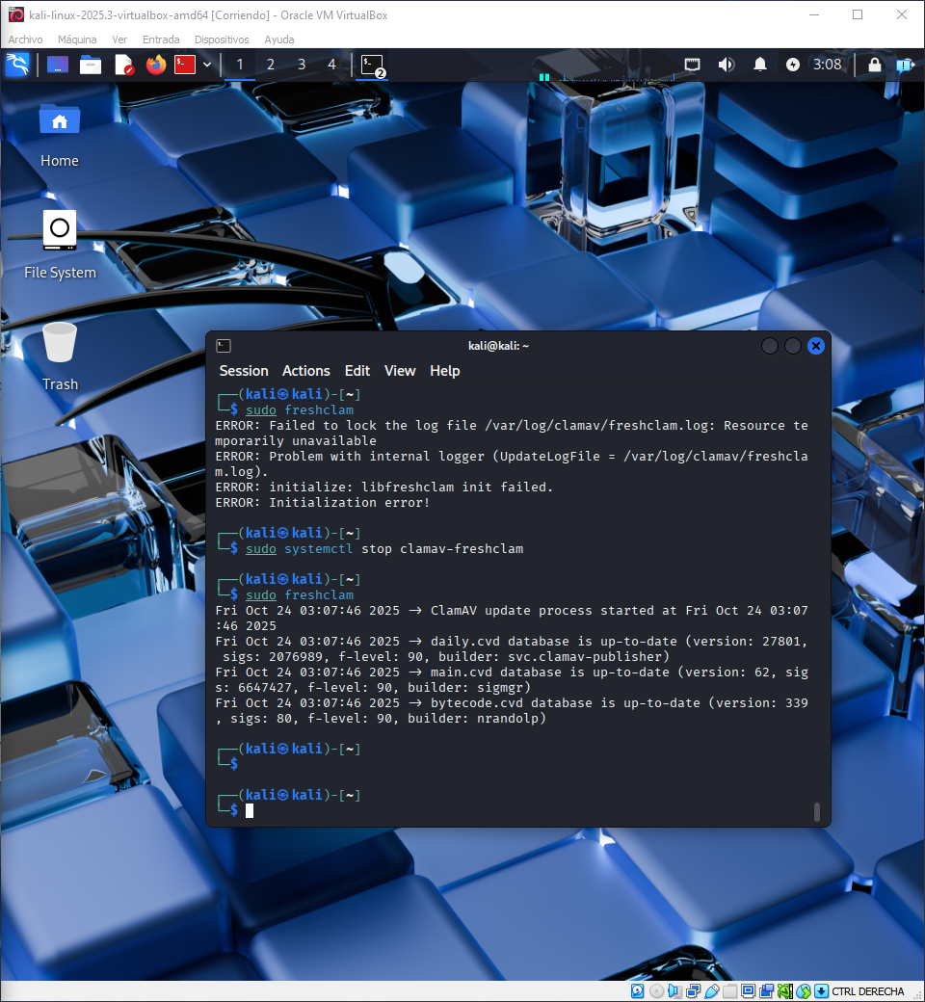

1. Escaneo con interfaz gráfica (ClamTK) 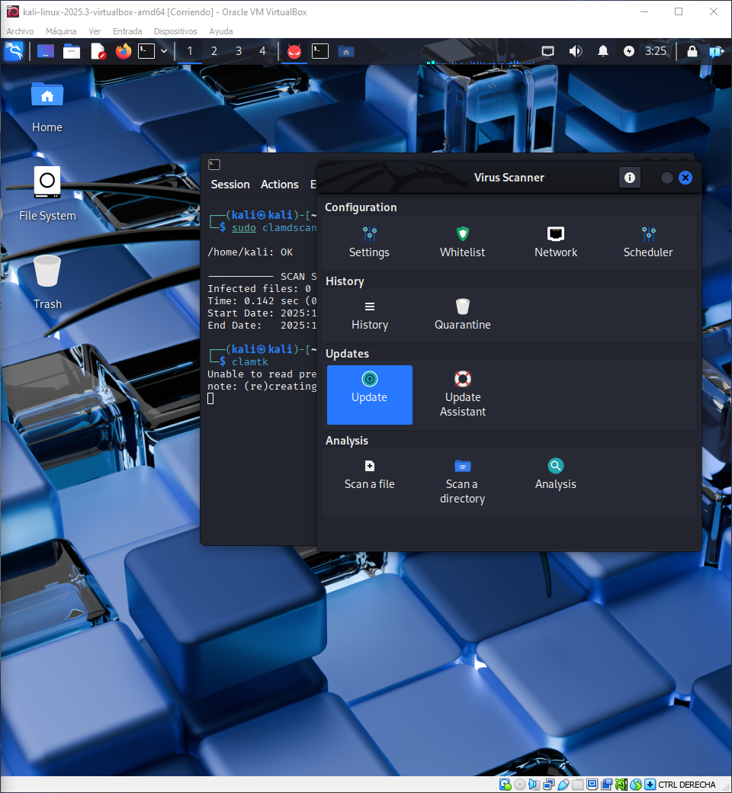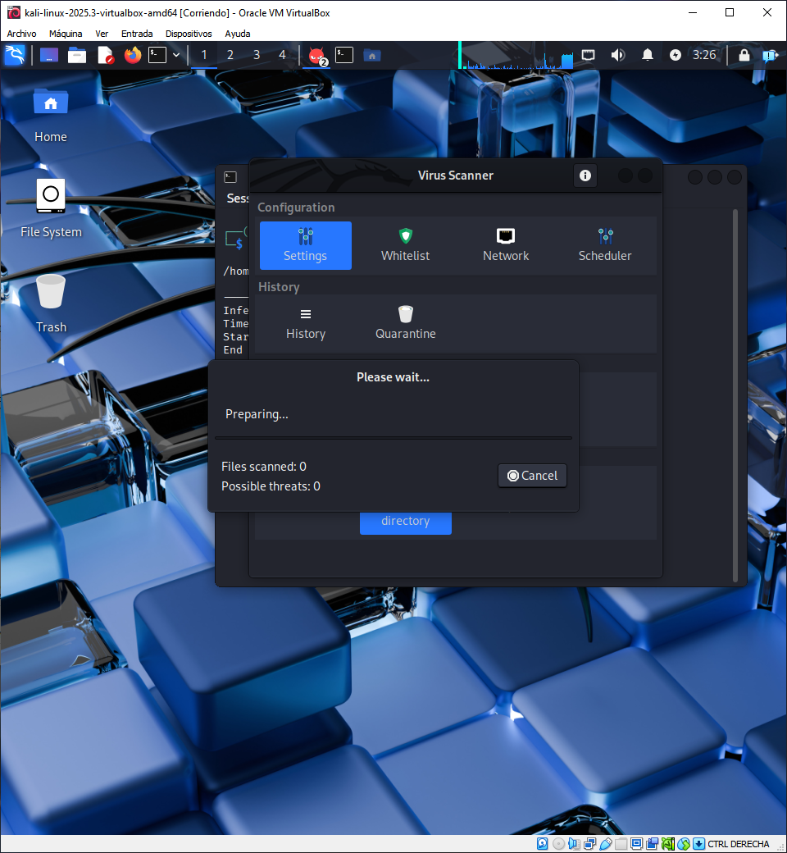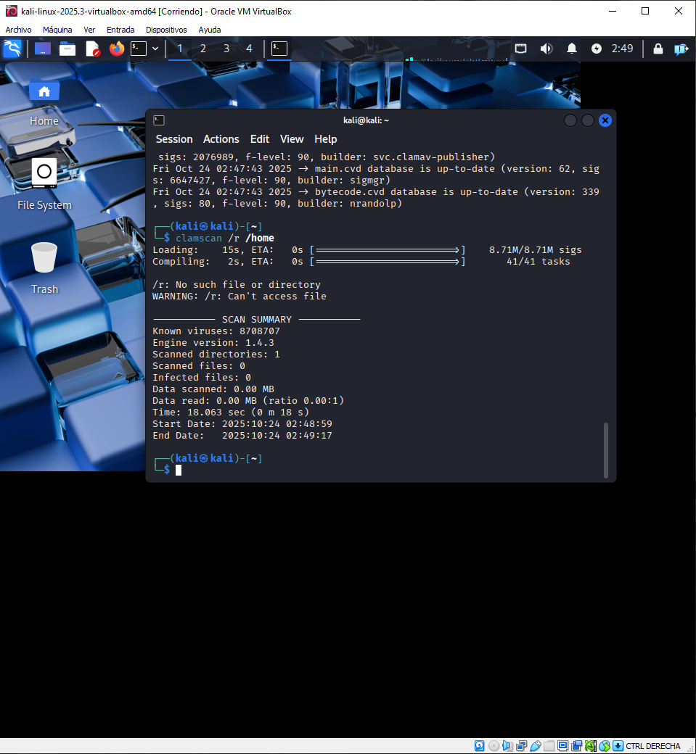

Ej 2:

1. Firewall en Kali Linux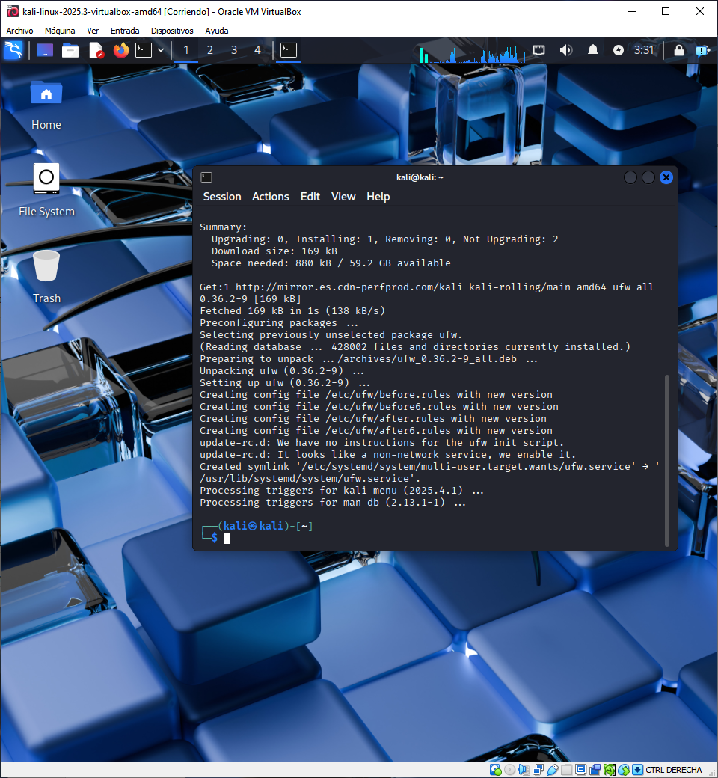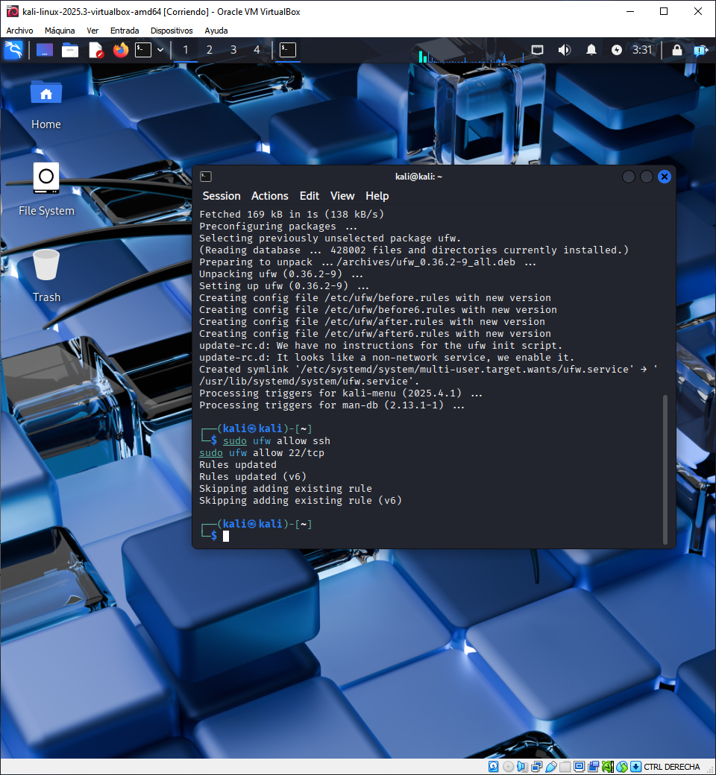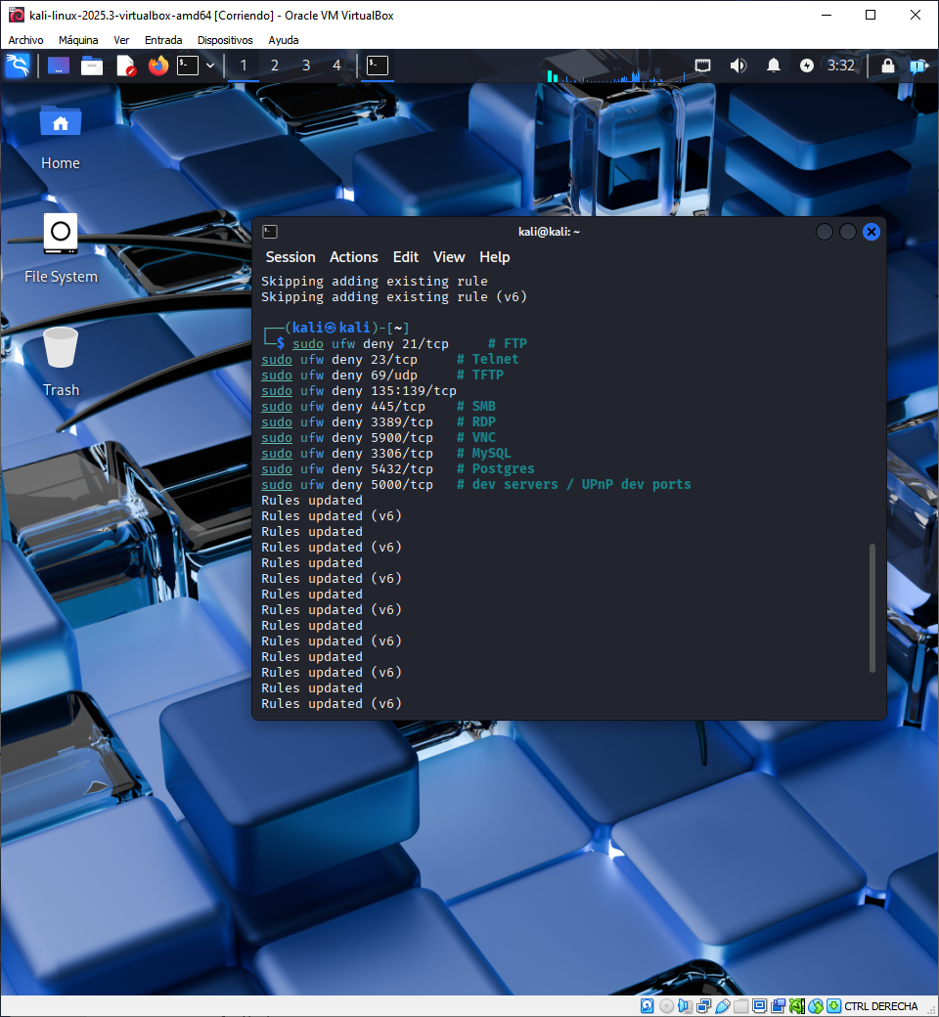
2. Guardar reglas y activar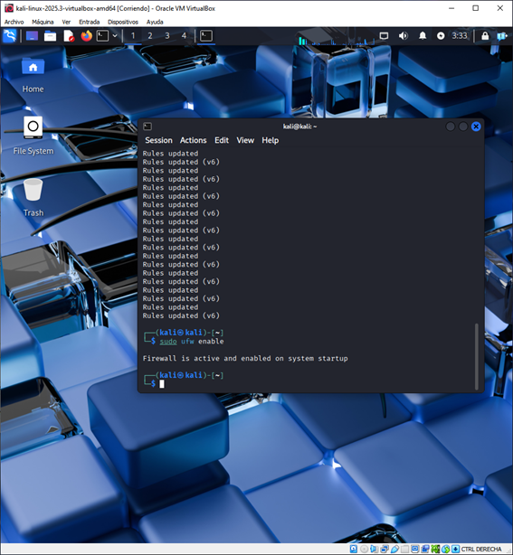
3. Verificar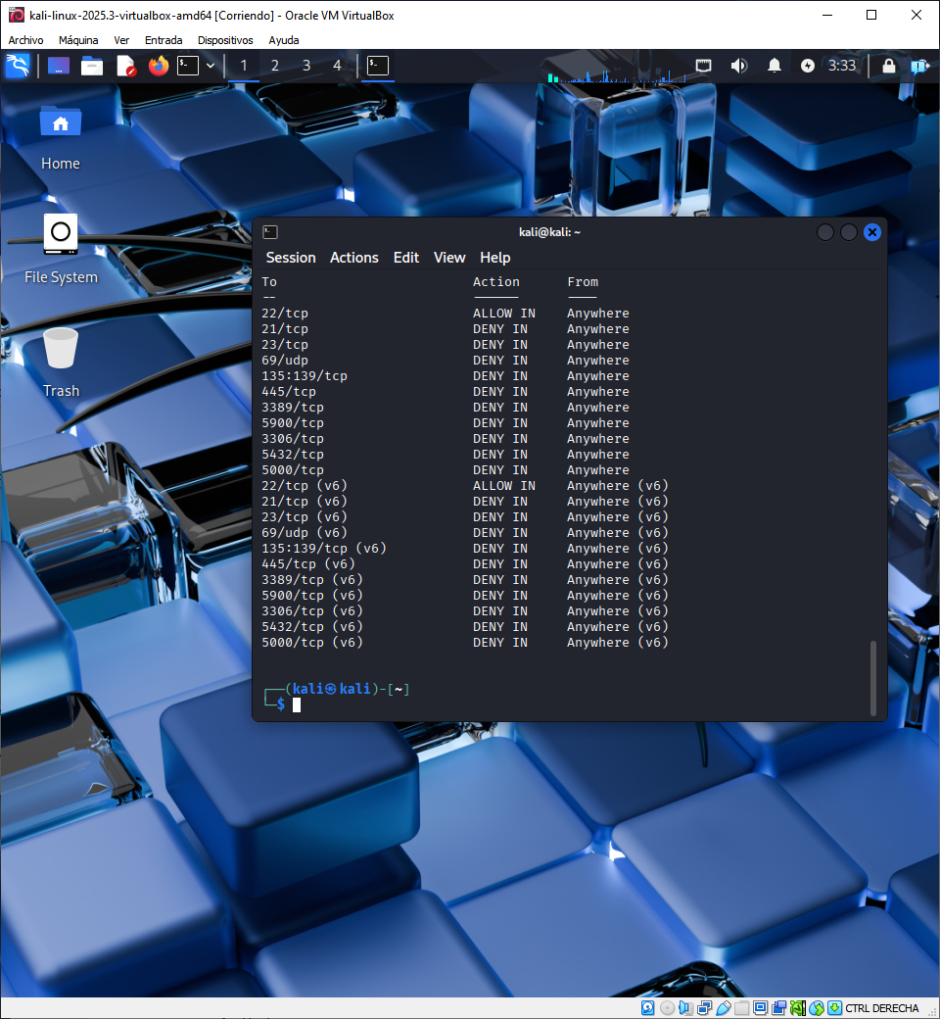
4. Configuración de firewall en Windows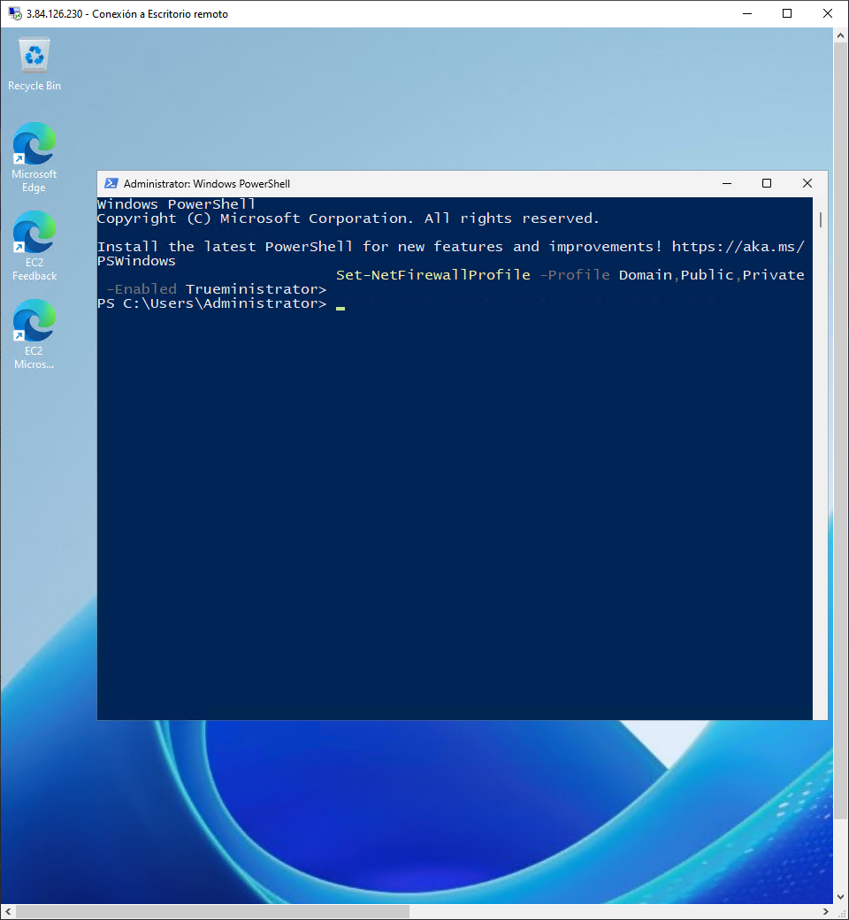

# Bloquear puertos TCP inseguros comunes (no incluye 3389)

* New-NetFirewallRule -DisplayName "Block TCP 21 (FTP)" -Direction Inbound -Action Block -Protocol TCP -LocalPort 21
* New-NetFirewallRule -DisplayName "Block TCP 23 (Telnet)" -Direction Inbound -Action Block -Protocol TCP -LocalPort 23
* New-NetFirewallRule -DisplayName "Block UDP 69 (TFTP)" -Direction Inbound -Action Block -Protocol UDP -LocalPort 69
* New-NetFirewallRule -DisplayName "Block SMB 135-139,445" -Direction Inbound -Action Block -Protocol TCP -LocalPort 135,137,138,139,445
* New-NetFirewallRule -DisplayName "Block TCP 5900 (VNC)" -Direction Inbound -Action Block -Protocol TCP -LocalPort 5900
* New-NetFirewallRule -DisplayName "Block TCP 3306 (MySQL)"-Direction Inbound -Action Block -Protocol TCP -LocalPort 3306
* New-NetFirewallRule -DisplayName "Block TCP 5432 (Postgres)" -Direction Inbound -Action Block -Protocol TCP -LocalPort 5432
* New-NetFirewallRule -DisplayName "Block TCP 5000" -Direction Inbound -Action Block -Protocol TCP -LocalPort 5000

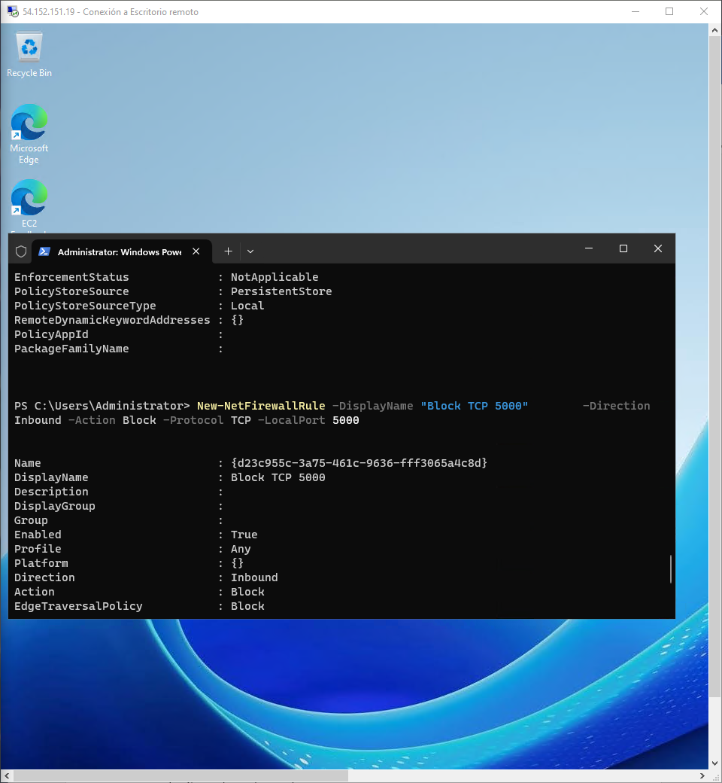

1. Comprobar reglas creadas